EXPERIMENT-8
Name: Sabitha.R Roll No:240701448
USER INTERFACE DESIGN
Create storyboards to represent the user flow for your application using Balsamiq here this software is used to show your application flow. which you can design the low fidelity prototype using the blasmiq normally the story board should create with comic scene. but here in this software you need to create the usage flow of the application in design in one screen.

Step by Step User Journey:
App Launch (The First Impression):
The journey begins with the BIGBITE application home screen. This screen shows the main navigation options such as Profile, Menu, Cart, and Favorite. This acts as the entry point where the user can easily choose what they want to do next. A logout option is also provided for quick access.
Menu Page (The Exploration Stage):
Next, the user navigates to the Menu page by clicking the "Menu" option. This screen contains a search bar at the top, allowing users to quickly find specific food items. Below that, food items are displayed in card format with images, names, and prices. The user can scroll through the list and explore available dishes.
Profile Page (The Personalization Stage):
When the user selects the Profile option, they are taken to the profile screen. This page displays the user’s avatar, name, and email ID. It also includes quick access options such as My Orders, Payment, Help, and Logout. This screen helps the user manage their account and track their activities.
Cart Page (The Selection Review Stage):
After selecting food items, the user moves to the Cart page. Here, all selected items are displayed along with their quantity and price. The user can increase or decrease item quantity using stepper controls. This allows flexibility before confirming the order.
Checkout Page (The Final Action):
At the bottom of the cart screen, a Checkout button is provided. When the user clicks this button, they proceed to confirm their order and move towards payment. This step ensures the user reviews their selections before placing the order.

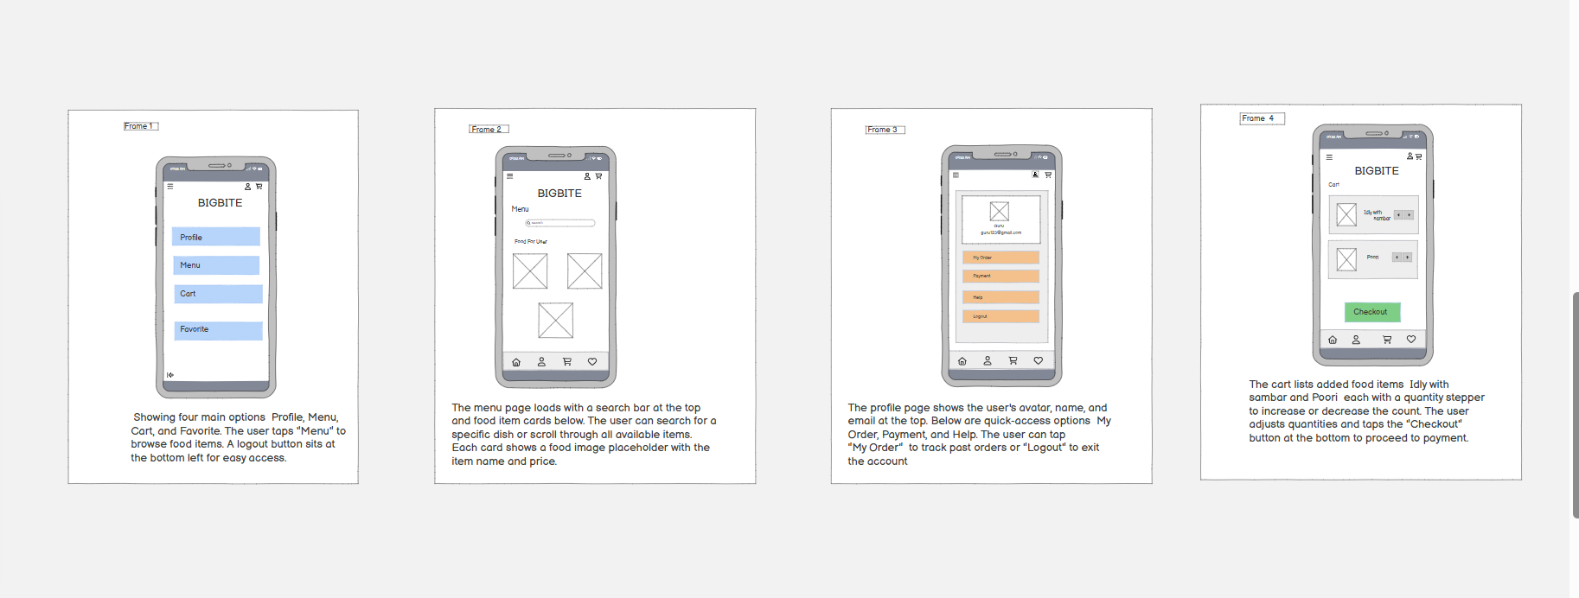
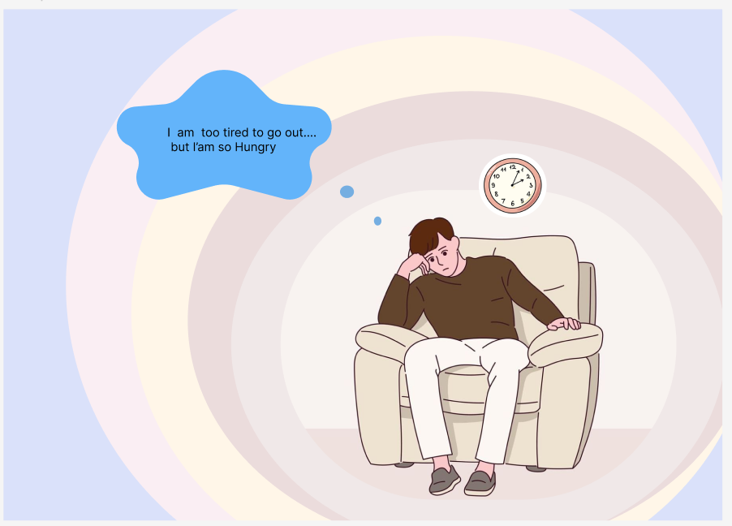

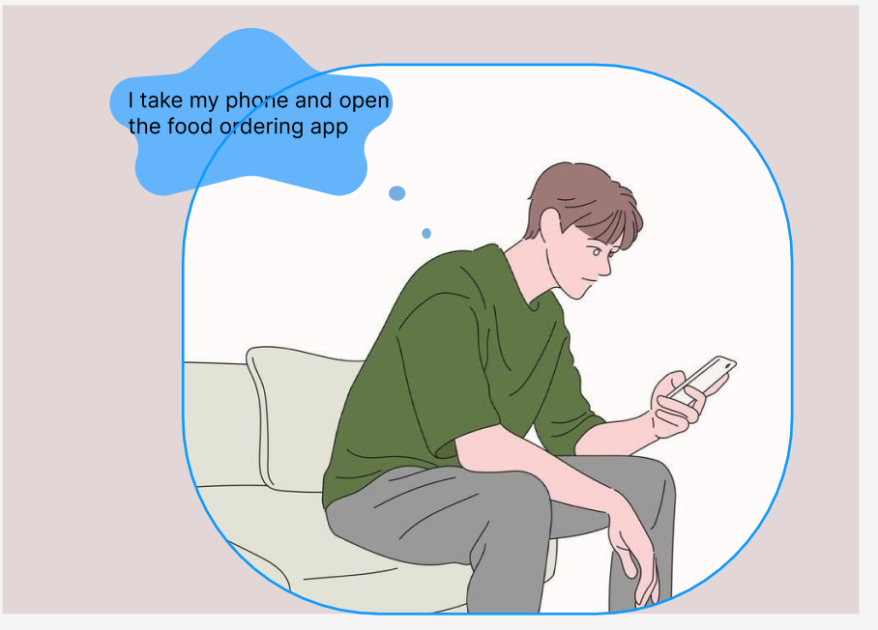
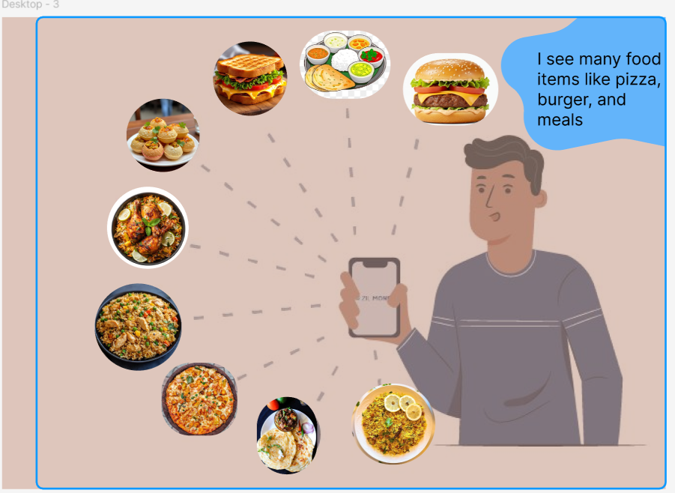

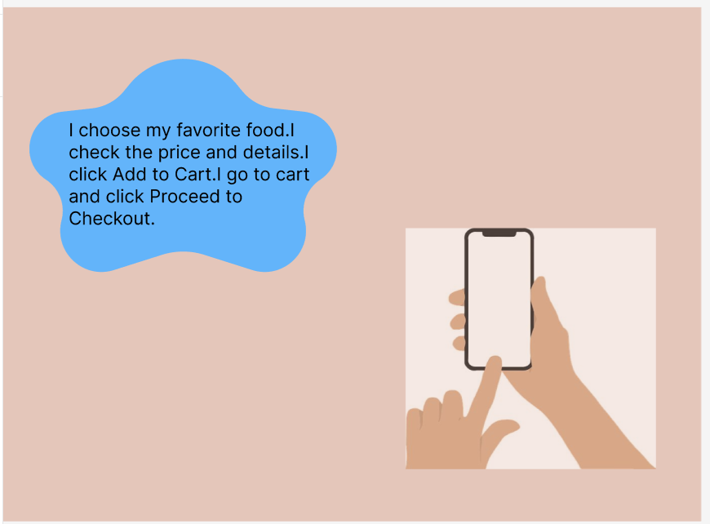
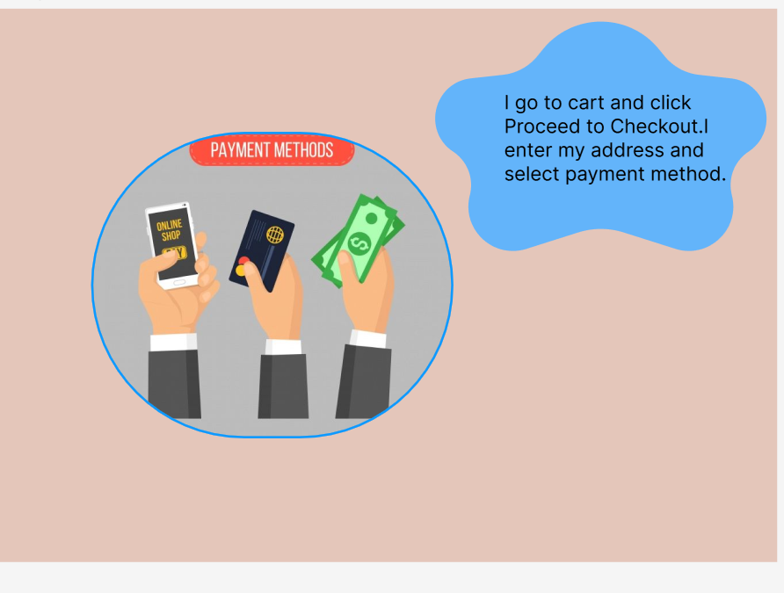

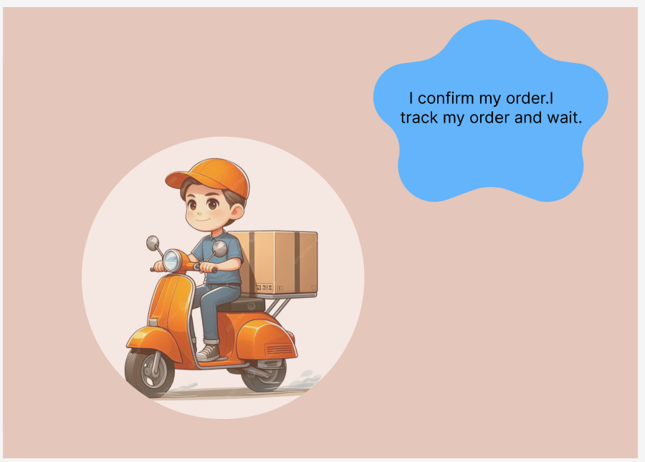
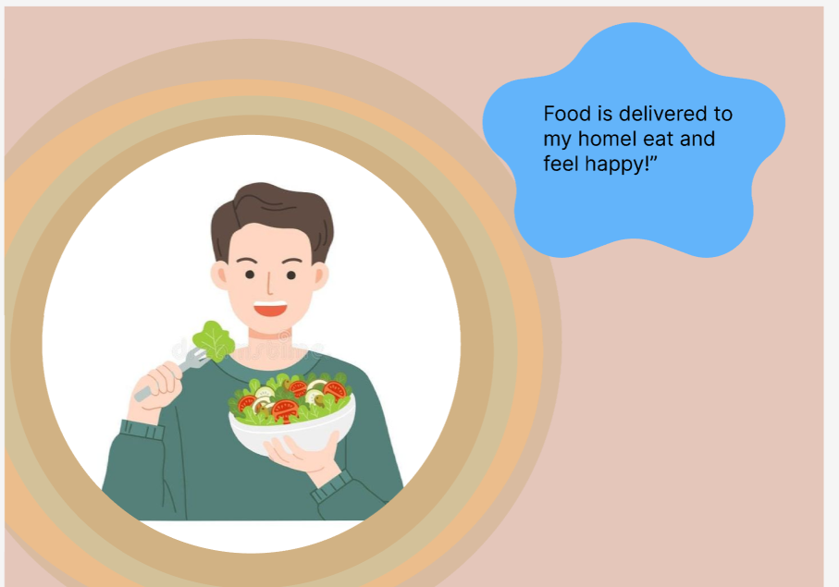

Wireframe link: https://balsamiq.cloud/sh42cvy/ppdhs3x
Figma link: https://www.figma.com/design/jOJE5ddedJBCADGQPq1mbB/Untitled?node-id=0-1&t=PBKtkuUvDYGBJBY

